PARTE 1.

Diagrama de flujo:

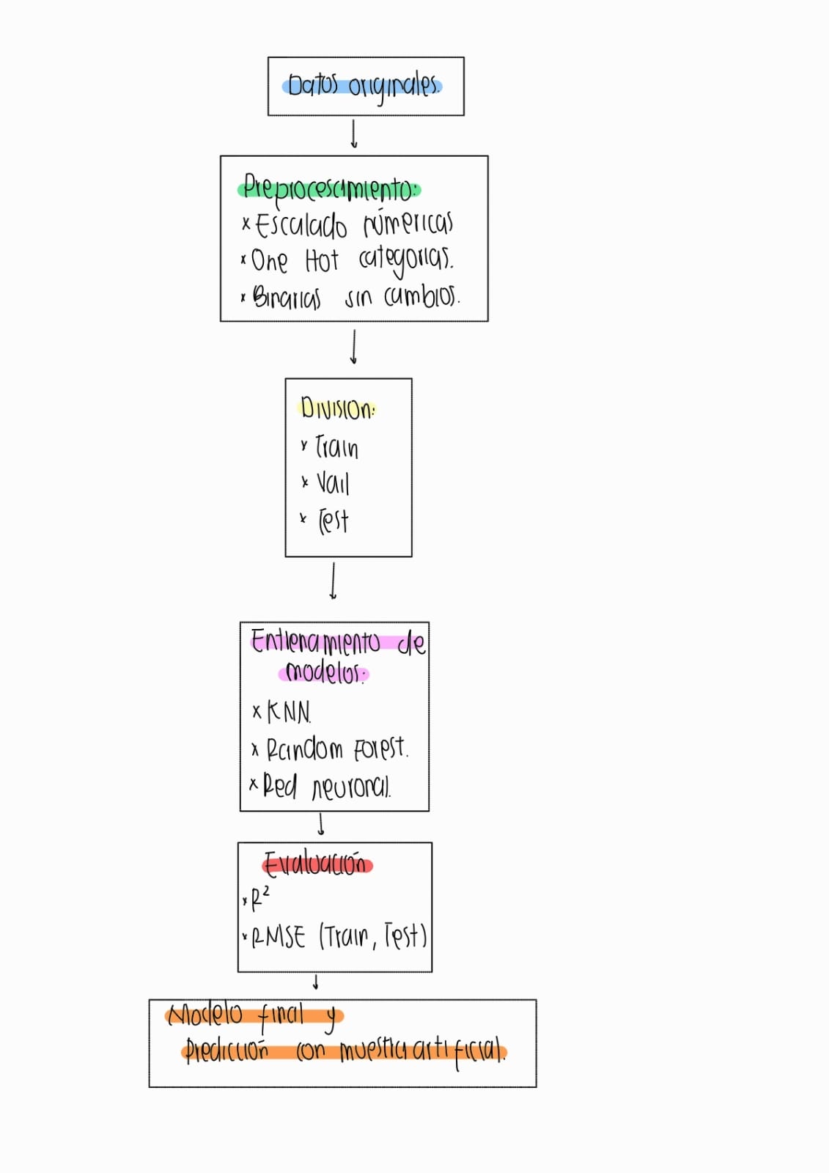

Tabla comparativa final de desempeño de modelos:

|  |  |  |  |  |  |  |
| --- | --- | --- | --- | --- | --- | --- |
| Dataset | KNN (R²) | KNN (RMSE) | Random Forest (R²) | Random Forest (RMSE) | DNN (R²) | DNN (RMSE) |
| Train | 1.00 | 3.71 | 0.9995 | 1.42 | 0.9929 | 5.26 |
| Val | 0.99 | 4.53 | 0.9963 | 3.81 | 0.9929 | 5.27 |
| Test | 0.99 | 4.62 | 0.9961 | 3.89 | 0.9927 | 5.30 |